IT Project Guidance

Solution Architecture Description Structure

Author

: Sky Sigal, Solution Architect

## Synopsis

Guidance on how to structure Solution Architecture Descriptions to achieve their purpose of reducing delivery risk of new or improved services.

# Introduction

A Solution Architect Description (SAD) is description of a complex system, described as Views from the perspective of different Stakeholder groups. Each View focuses on information about the service that is relevant to their intended audience’s Role.

Purpose

The purpose of a SAD is to reduce delivery risk, by

* Developing designs of what is reasonable to determine before work commences.
* Such that it can be described for review and approval by appropriate stakeholders’ the key aspects of an overall interconnected design and delivery plans for the proposed service.
* Keeping the plans up to date to provide different delivery stakeholder groups current and trustable instructions.

# Dependencies

The development of SADs depends on prior work being completed. These artefacts are the project’s Solution and Transitional Requirements, which in turn rely on Tools having been developed.

## Business Analysis

Key Tools that Stakeholder Analysts develop first include

* stakeholder maps

#### Stakeholder Map

A Stakeholder Map is the artefact used to capture and show the wide set of stakeholders that were considered.

This catalogue is used to guide stakeholders to query each group for functionality and qualities they desire from the service and its systems.

## System Analysis

Key tools that stakeholder analysts develop to map the functionality required of a system may include:

* user persona maps,
* user journey maps

### User Persona Map

A SAD’s functional View describes how the system provides the functionality expected by a wide range of users.

A User Map is the artefact used to capture the wide range of users that use a system over its operational service lifecycle. It will include at the very least:

* Business Service Consumers: the intended recipients of the service. End Users are categorised into Roles that best describe their role in their own organisation (Principal, Admin, Accountant, Teacher, etc.)
* General Support Specialists: provide general assistance to Service Consumers that is not specific to Business functions. This may include helping with provisioning new user groups, authenticating users, etc.
* Business Support Specialists: providing business assistance to Service Consumers. This may include onboarding groups of new users, assigning them with initial roles, setting up preferences, etc.
* Operations Specialists: providing support to Business Support Specialists.
* Training Support Specialists: providing Business Service Consumers, General Support Specialists, Business Support Specialists and Operations Specialists introductions to service capabilities, and knowledge on how to use the service’s provided functionality.
* Etc.

## Solution Requirements

Stakeholder Analysts use the Stakeholder and User Map to guide the collection of Desires, which they in turn use to develop Requirements.

BABOK recommends the development of

* Solution Requirements, comprised of
  + Functional Requirements
  + Quality Requirements
* Transitional Requirements

### Qualities Requirements

A System’s Quality Requirements describe how a system is expected to operate – regardless of its Functionality.

A set of subjects are provided in ISO-25010, ISO-25012, ISO-25022’s to guide the development of a set of Requirements that do not omit important aspects.

It is common but not obligatory that a SAD includes a matrix demonstrating how the desired Qualities are met by system design. The Qualities Matrix may be presented either as part of dedicated Qualities View or relegated to an Appendices.

### Functional Requirements

Functional requirements are developed by stakeholder analysts querying the stakeholders listed in a Stakeholder and User Map.

The design of a system described by a SAD should attempt to provide functionality that meets most of these Functional Requirements.

It is common but not obligatory that the SAD tracks via a matrix which Requirements are met by which designed Functionality.

## Transitional Requirements

In addition to referencing Solution Requirements, Architects should reference Transitional Requirements.

Transitional Requirements outline requirements for transitioning between states – generally ‘now’ and ‘release’.

Transitional Requirements will include the development of comms, conditions (T&Cs, Privacy & Tracking Statements, expected Comportment/behaviour, processes (onboarding, supporting, offboarding), system initialising & configuration, provisioning (reference data, users), etc.

An architect developing a design should design a solution that provides a means of meeting these transitional requirements.

# Platform

The first iteration of SADs is developed prior to going out for RFP, and therefore must be developed or exportable to a platform available from outside the organisation by non-authenticated readers.

After Procurement has concluded, SADs must be accessible by both internal business and delivery stakeholders, but also 3rd party consultants and collaborators without their needing to be members of an organisation.

SADs must be versionable for auditing and accountability reasons, to determine who changed what and what has been presented and accepted by governance steering groups.

SADs benefit from being improvable via Comments being able to be added.

For the above 3 reasons, the development of SADs has traditionally been within Word documents.   
Use of a different platform is acceptable if it both provides additional benefits and meets a similar level of availability, improvability and auditability.

Diagrams

There is no universally accepted diagramming convention. Options include

* + - * Simple arrowed “Boxes and Lines” diagrams
      * UML (ISO-19505-2:2012)
      * Entity Relationship Diagrams (ERD)
      * Archimate
      * C4

While there is no clear advantage or accepted domint style, it is our recommendation to using simple plain boxes and lines to communicate to the widest set of audiences wherever possible, optionally *supplementing* them in specific views with industry specific diagrams, depending on the purpose:

* + Archimate in Business Context Views,
  + Entity Relationship Diagrams (ERD) in Information Views,
  + UML Use Case diagrams in Functional Views,
  + UML Communication diagrams in Integration Views
  + UML Sequence or Activity Diagrams in Sequence Views,
  + UML Deployment diagrams in Deployment Views
  + UML Class diagrams in Development Views

Note: C4 can also be used.

## Length

A SAD is not meant to be read in its entirety by any stakeholder group – including quality reviewers.

While not a novel, it is neither a summary[1]. It is a reference artefact whose purpose is to reduce unnecessary risks to delivering the expected service by being reviewable by both non-technical and technical stakeholders.

Its length should be the length necessary to decrease the risk of misunderstanding how to implement the Solution. Depending on the project, it can get long[2].

## Duplication

Moderate duplication of information across Views is acceptable where information relevant to one stakeholder group may be also relevant to another stakeholder group.

# Structure

## Background

The structure of Solution Architect Descriptions have evolved over time from “4+1” – the dominant methodology of organising SADs in the 90’s -- to the one advocated in ISO-42010:2011, popularised by Rozanski & Woods’ seminal book.

### ISO-42010: Architecture Description

[](http://skysigal.com/_media/resources/images/00/sad/views.png)

Figure Traditional Architecture Model Plans, Elevations, Sections

ISO:42010:2011 Architecture Description specifies how complex systems should be described using a series of interrelated Views (sections) viewed from the perspective of different Stakeholders groups.   
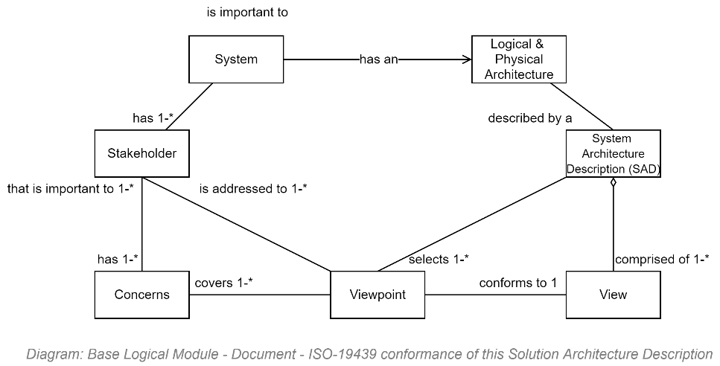

Figure : ISO-42010 Components

The standard does not proscribe what the Views should be and leaves it up to the architect.

### Rozanski and Woods Recommended Views

To address ISO-42010’s gap (of not proscribing a set of View titles to use), Rozanski and Woods published a seminal book describing how to develop SADs in adherence to ISO-42010.

## Use Cases

SADs are developed before RFPs and after Procurement has completed.

Before procurement, the view of what system will be used is limited.

### Before RFP

Views may include the following:

* Requirements Realisation Viewpoint.
* Application Usage Viewpoint: what flow is required to complete an action, and what systems were interacted with?
* Technology Viewpoint:
* Migration Viewpoint
* The following may not be required:
  + Capability Map Viewpoint
  + Product Viewpoint
* Application co-operation View: which applications expose and consume which service?
* Application Structure View: which application perform what functions.
* Product View: what products depend on which applications?

## Sections

While R&W improved on the sparse guidance provided in ISO-42010, it too had unclarity.

The following is a list of proposed Views to consider and select from when developing SADs.

##### Context View

: aimed for validation by Business Sponsors and consumption by all stakeholders. the Context View summarises key aspects of the project.   
It is our recommendation to outline the same aspects as would be covered in a BOSSCARD summary. Specifically, it should outline the Background, Problems, Constraints, Opportunities, Assumptions, Stakeholders, Options, selected Option, its Risks, Scope, and expected Deliverables.  
Note that Constraints include Regulations, Policies and Agreements. The Regulations include the applicable laws, for example, and Agreements include both national ones (e.g.: UN) and project-specific Guiding Principles, stating that they align with the Enterprise collection of guiding principles.

### Delivery View

: aimed at Project Managers tasked with organising and prioritising delivery of all artefacts required to deliver an automated business service.   
It outlines the tools used to automate the collection, coordination, prioritisation of user voice to work items to delivered Deliverables expected by different stakeholders. This will include the system of course, but also People, Roles, Decision, Risk and Issue Registries, Development Guidelines, Certificates, Organisation website content media, Deployment Pipelines and their maintenance instructions, Application Support Guides (ASGs) for Support Specialists, Operations manuals, System Media in various languages, etc. Describing the Change Management is a key aspect of this View.

### Qualities View

: describing the ISO-25010, 25012 and 25022 Qualities expected of the service -- irrespective of the actual functionality described elsewhere in the Functional View -- and how they are addressed.   
Note that where newcomers may be confused by ISO-25010 Qualities having a Functionality Completeness

### Privacy View

: describing how the system’s information meets privacy expectations

### Security View

* : describing how the system meets and exceeds security (in transit, at rest) and accessibility and auditability expectations.

### Capabilities View

* : describing the capabilities expected of the service. Capabilities are delivered by specific functionality, described in further detail in the *Functional View*.

Describe the capabilities in tiers aimed at different stakeholders. For example, describe business capabilities first, indicating that they in turn rely on underlying generic information service, which is described in a subsequent section.

*Note that most systems will include most of the following capabilities -- Diagnostics, Error recording, Configuration, Settings, Session, Discovery, Routing, Authentication, Authorisation, Search, Versioned Agreements (T&C) Management – on which specific Sector or Business capabilities can be built upon.*

### [Logical] Information View

:   
…Conceptual, Logical, not physical (anymore).   
  
Dataflow summaries (User to System to System).

**Authorisative Sources.**

**Codesets/Reference Data**

**Classification.**

##### Functional View

: the functionality provided to manipulate the above information. It is common to outline business consumer and support specialist functionality first, and the describe how the expectations of other stakeholders (Support, Operations, Maintenance, Security, etc.) are also met.

##### Interoperability View

: describing how the above functionality is made accessible to authenticated and authorised 3rd party systems via audited APIs.

##### Sequences View

: covering sequences, such as OAuth and OIDC authentication flows, processing workflows, and state change processes (Draft to Released),

##### Component View

: covering the way the system’s logic is broken down to distinct deployable units. Often references DDD.

##### Integration View

: describing how the system devices and components are integrated. integrations required to IdPs, Cache, Data stores, Geo/IP Services for geoblocking, and Malware detection within uploaded media.   
  
Integration Flows/Sequences, (small piece of overall dataflow diagram, more detail) PASS/FAIL.

##### Deployment View

* : describing how the system’s components are deployed to target virtual infrastructure.

##### Development View

: describing agreed Development Principles and Patterns to use.

##### [Datastore] Information View

* : describing datastore elements. Note that while it used to be common to describe in detail a system’s database schema, this perception is dated: data storage is understood to be an internal development concern best left to be described -- if needed -- in a Technical Design Document (TDD) of some form**.**

##### Appendices

* : for inclusion or reference to a 3rd party glossary, quality and functional matrices, etc.

Table : Catalogue of recommended ISO-42010 Views

Each of the above views is for reference and review by specific stakeholder groups to provide answers to their queries about Organisation Strategy, Business Services, Security, Privacy, Information, Development, Infrastructure, Deployment, Communications, etc.

Note the following:

* Integration – a deployment aspect – is presented separately to Interoperability – a capability,
* Deployment – a technical view used to describe the use of automated compilation, packaging, deployment and testing pipelines, is distinct from the Delivery view which covers Change Management aspects (Comms and similar transitional requirements).
* Security and Privacy are Views in their own right, rather than view-embedded Perspectives as Rozanski & Wood first proposed, as the subjects have gained importance since 2000, and they need to be prepared for specific stakeholder group audiences to review during accreditation.

Appendices

Appendix A – Document

### Diagrams Index

Figure 1 Traditional Architecture Model Plans, Elevations, Sections 7

Figure 2: ISO-42010 Components 7

### Tables Index

Table 1: Catalog of recommended ISO-42010 Views 8

### References

“Default Project - Baseline ICT Terms & Acronyms Glossary”

## Appendix B - Diagram Examples

The following are examples of diagrams that can be included in SADs where appropriate.

### Business Context View Diagram Example

#### Stakeholder Map

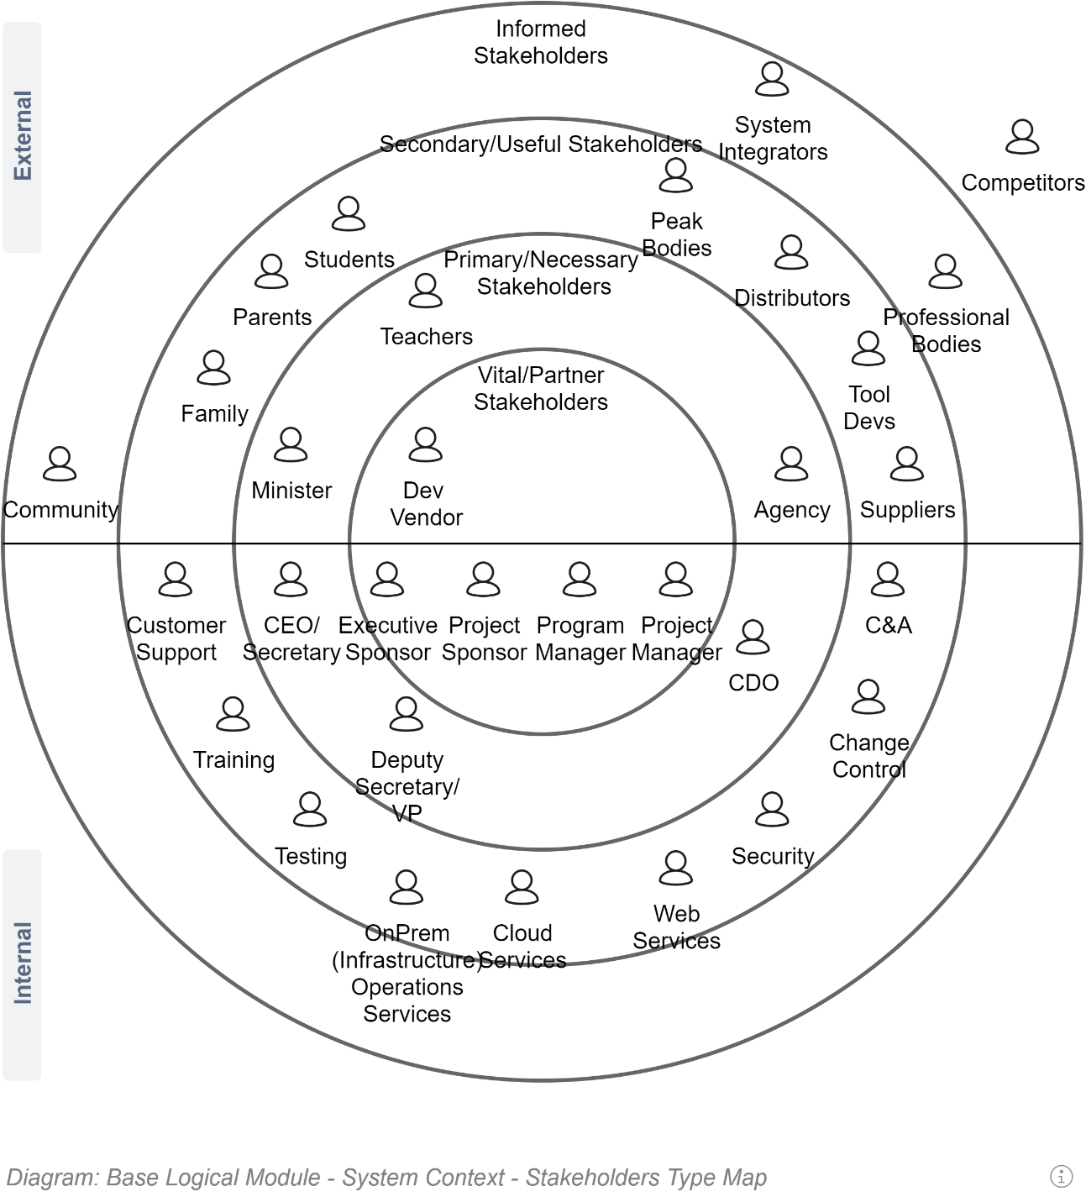

### Principles Map

It is optional to include a diagram to summarise Agreed Principles that the team has to follow:

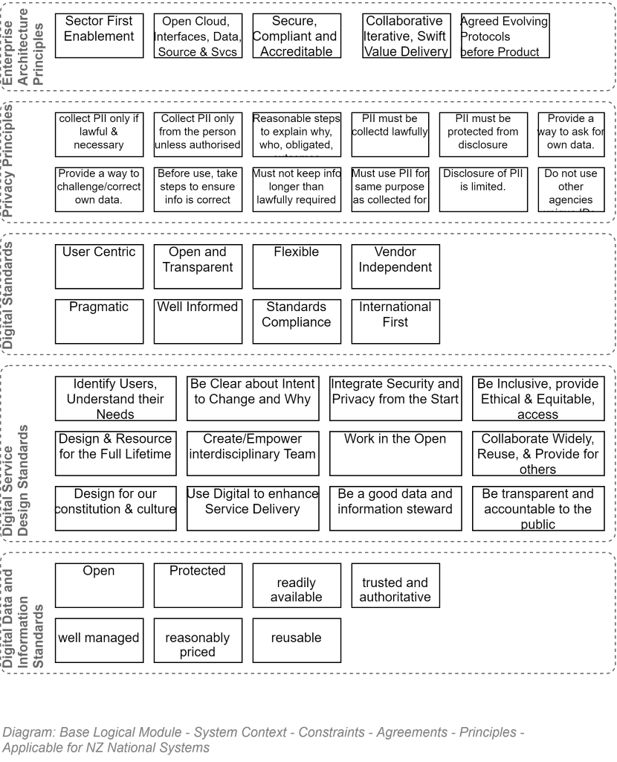

### Delivery View

#### Influence Map

An influence map is an reorganisation of a stakeholder map in terms of their influence on the priority of workitems.

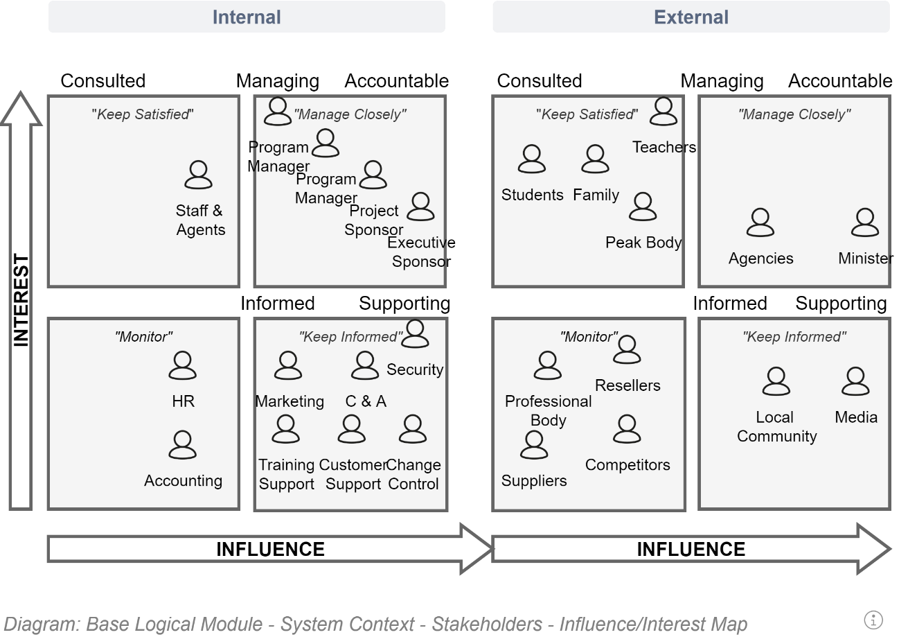

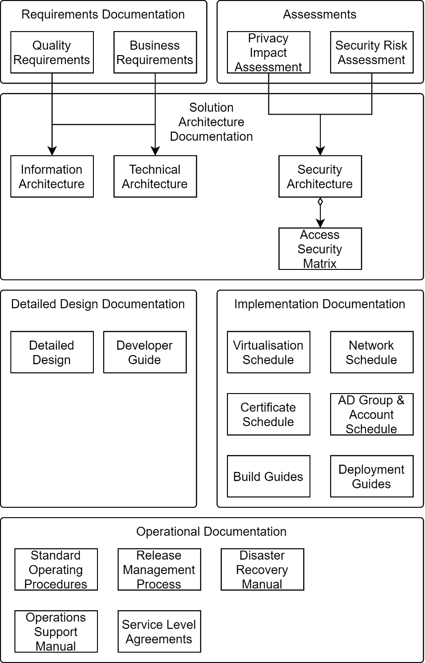

#### Deliverables Map

It is optional to include a diagram that summarises the deliverables that need work item development and tracking by a delivery manager.

The following diagram is an example of a delivery map of technical deliverables required for a simple information system.

It is incomplete as it does not include reference to Transitional Requirements beyond those needed for the system itself.

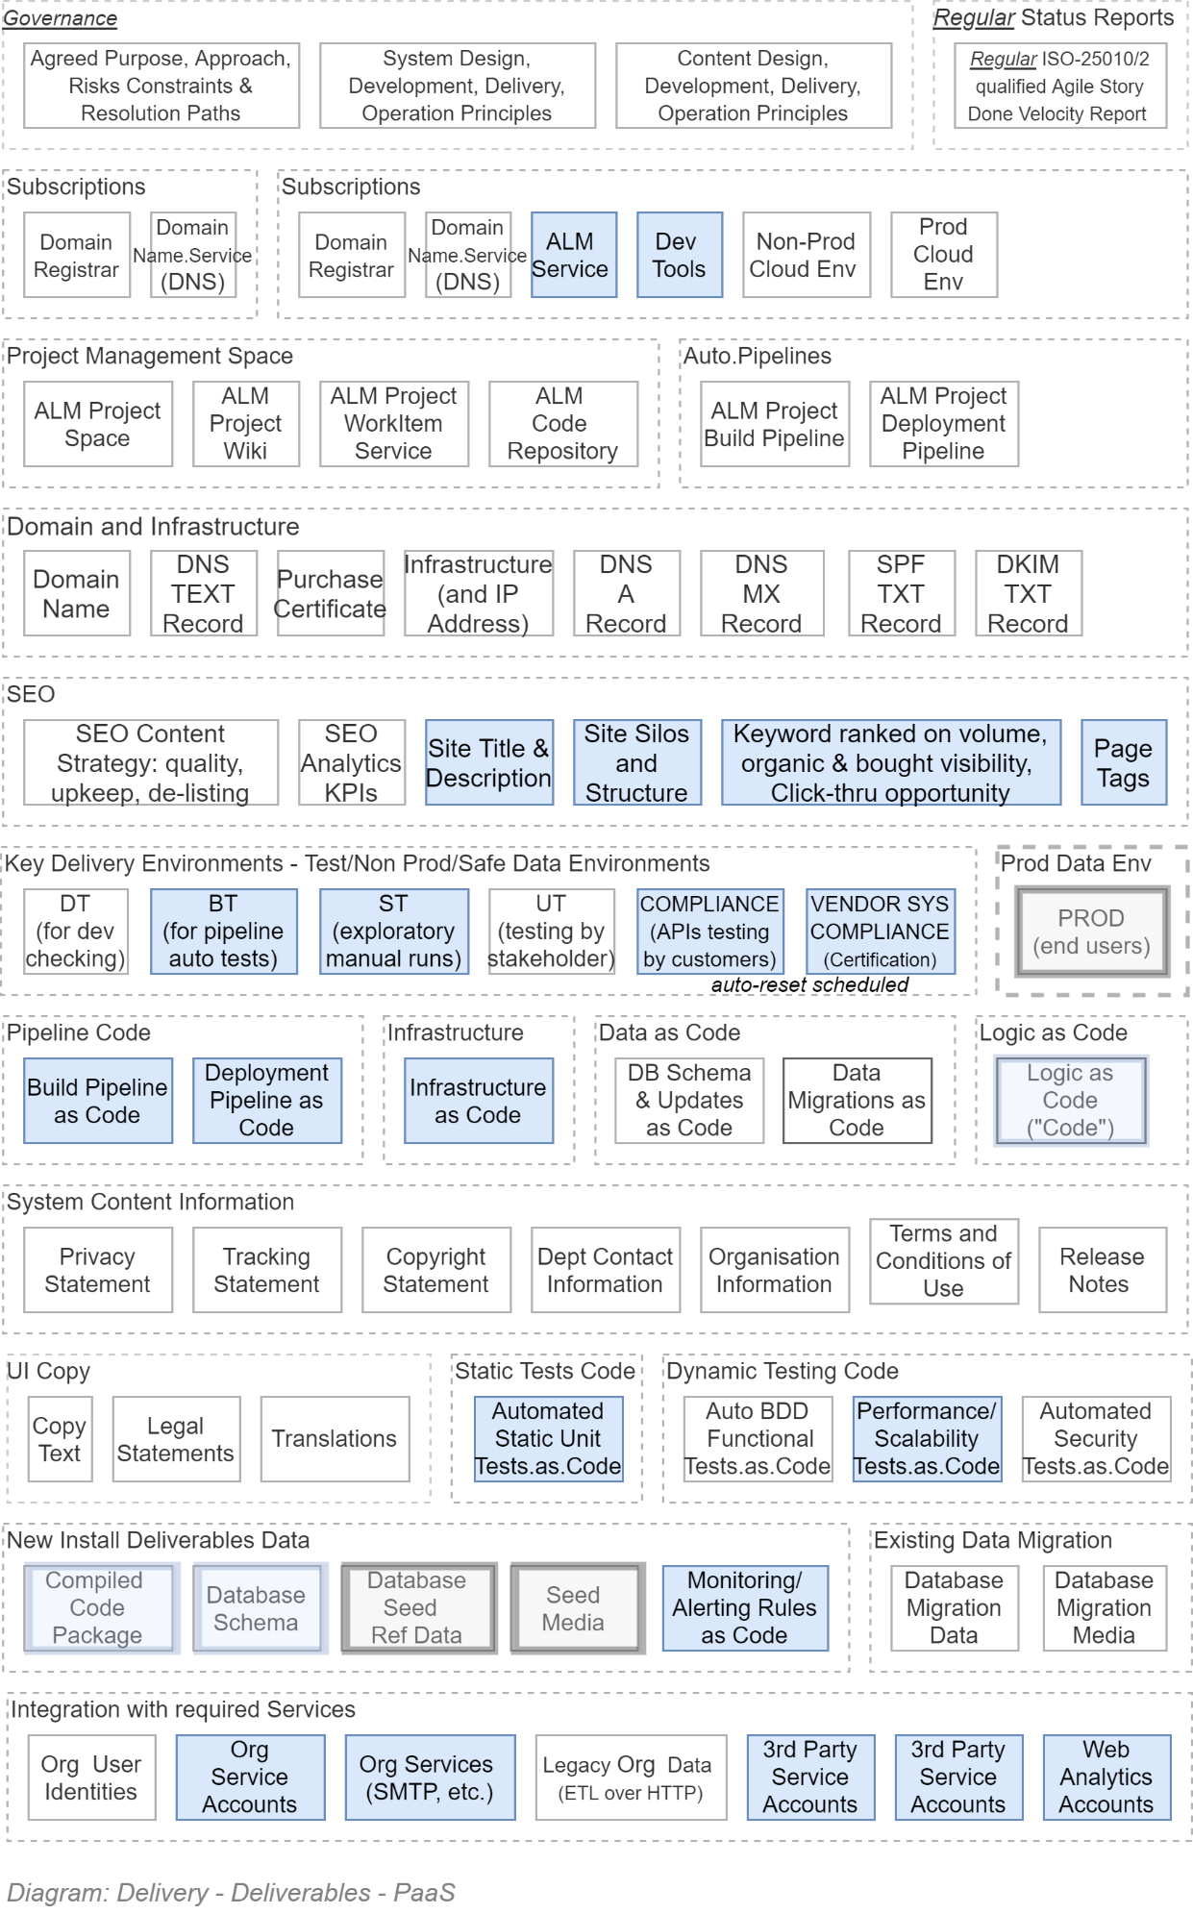

1. Develop a separate succinct artefact (e.g.: either a PP or A3 based “Architecture on a page”) to summarise to governance groups.
2. Making the document a GLAD (Gloriously Long Architecture Document)?